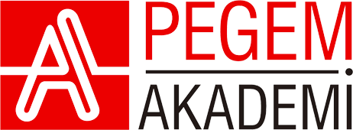

**Educational Research & Implementation**

ISSN: 3023-6568 (Print) 3023-6576 (Online) Journal webpage: <https://www.edure.net>

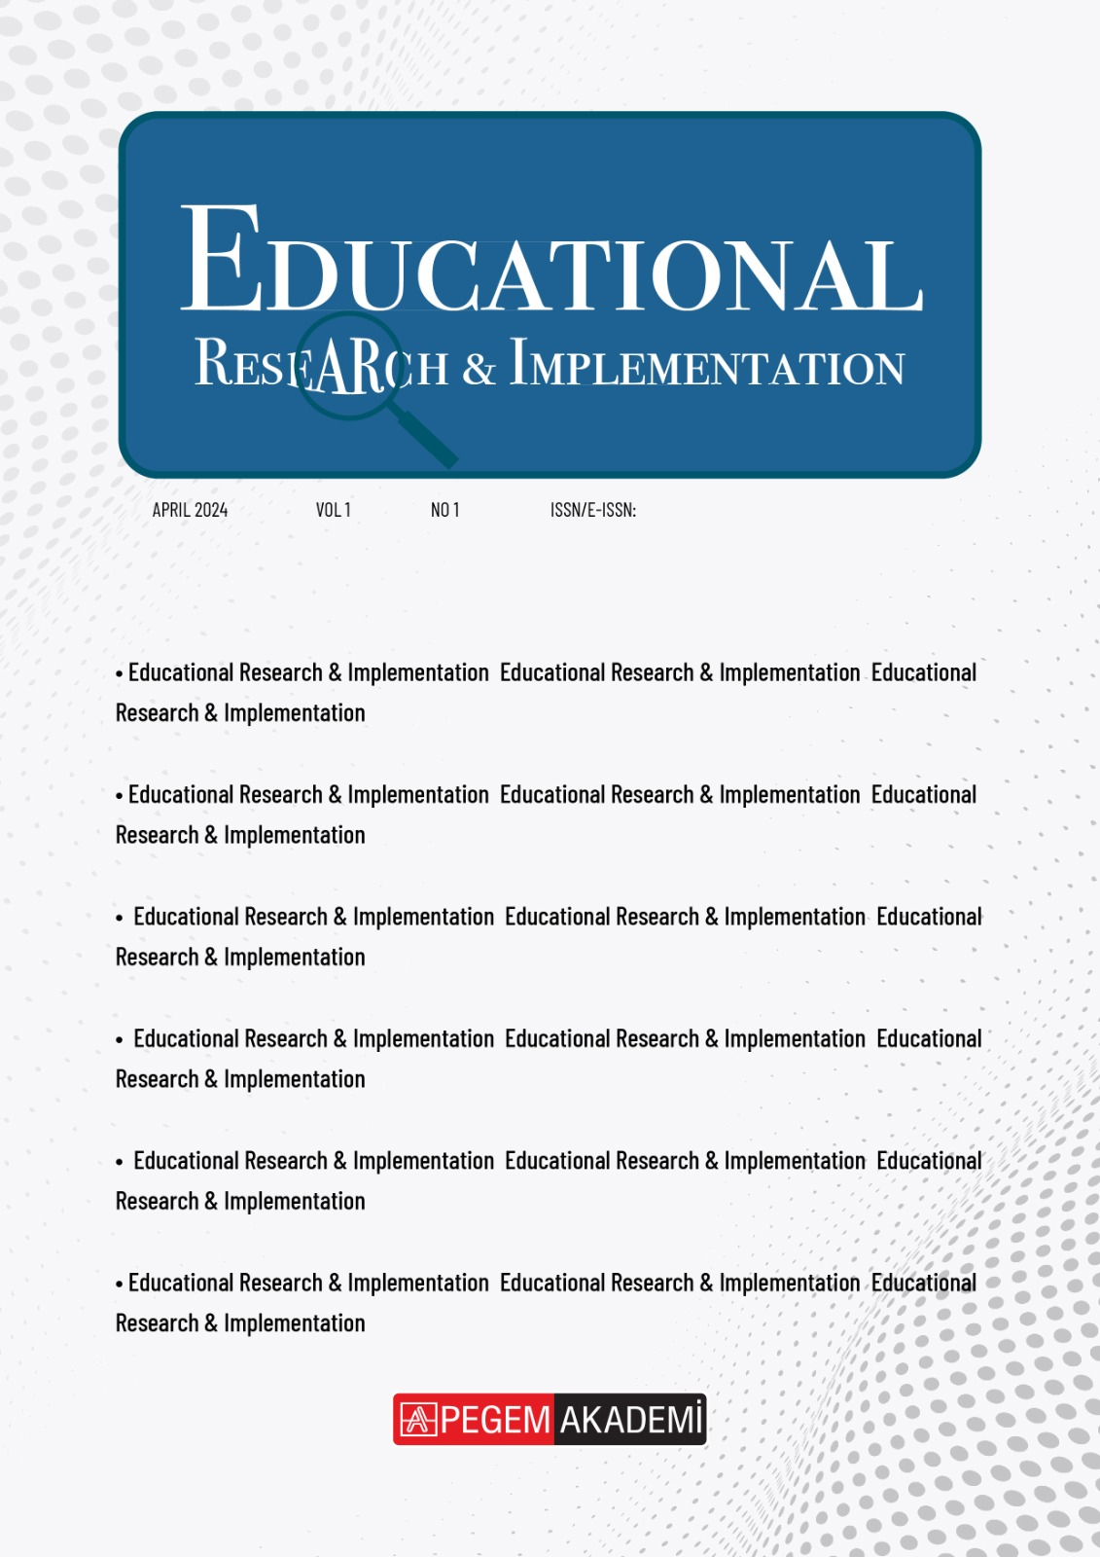

**LICENSE AGREEMENT**

**Please provide the information requested, familiarize yourself with our policies and the license agreement, and confirm your acceptance of the terms.**

|  |  |  |
| --- | --- | --- |
| **Article Title** | **:** | **……………………………………………………………………………………………………….** |
| **Author(s)** | **:** | **……………………………………………………………………………………………………….** |
| **Date** | **:** | **April 22, 2024** |

As a government employee, the article falls within the public domain, rendering the "License of publishing rights" clause inapplicable.

I am the sole author of the article. There is no one who contributed to the research.

The article is co-authored, and I am authorized to sign on behalf of all other authors.

**Please select one or more of the boxes above (as applicable), carefully review the License Agreement, and proceed to sign and date the document accordingly.**

|  |  |  |
| --- | --- | --- |
| **Corresponding author:** | **:** | **……………………………………………………………………………………………………….** |
| **Title and Company** | **:** | **……………………………………………………………………………………………………….** |
| **Signed** | **:** | **……………….** |
| **Date** | **:** | **April 22, 2024** |

**Please sign the License Agreement and upload it to the system.**

**THE LICENSE AGREEMENT**

License of publishing rights

I hereby provide Journal Owner (Pegem Akademi) with an exclusive license for publishing and distributing the manuscript mentioned above, including any accompanying tables, illustrations, or materials submitted for publication as part of the manuscript (referred to as the "Article"). This license extends to print, electronic, and all other forms of media, both existing and future, in all languages and territories worldwide, for the entire duration of copyright. Pegem Akademi also has the right to sublicense these rights to others. This license becomes effective upon acceptance of the Article for publication and includes the authority to enforce these rights against third parties.

Supplemental materials

Supplemental Materials refer to materials published as an additional part of the Article, encompassing graphical, illustrative, video, and audio content, among others. Regarding any Supplemental Materials I submit, Pegem Akademi shall possess a perpetual worldwide, non-exclusive right and license to publish, extract, reformat, adapt, expand upon, index, redistribute, link to, and otherwise utilize all or any portion of the Supplemental Materials. This permission extends to all forms and mediums, regardless of current or future development, and Pegem Akademi is also permitted to authorize others to do the same.

Research data

"Research Data" refers to the outcomes of observations or experiments validating research findings, published separately from the Article. This may encompass raw data, processed data, software, algorithms, protocols, and methods. Regarding any Research Data I intend to make accessible on a site or through a service provided by Pegem Akademi, Pegem Akademi is granted a perpetual worldwide, non-exclusive right and license. This license allows Pegem Akademi to publish, extract, reformat, adapt, expand upon, index, redistribute, link to, and otherwise utilize all or any part of the Research Data across all forms and media, including those developed in the future. Furthermore, Pegem Akademi is authorized to permit others to do the same. If I have chosen a specific end user license for the Research Data on a particular site or service, Pegem Akademi will apply that end user license accordingly.

Communication rights

I acknowledge that I retain the copyright in the Article, and no rights in patents, trademarks, or other intellectual property rights are transferred to the Journal. As the author of the Article, I understand that I shall have the following rights:

* The same rights to reuse the Article as those allowed to third-party users under the CC-BY-NC-ND License.
* The right to use the Article in a subsequent compilation of my works or to extend it to book-length form, include it in a thesis or dissertation, or otherwise use or re-use portions or excerpts in other works, for both commercial and non-commercial purposes.

However, except for such uses, I understand that the publishing rights license granted to the Journal gives the Journal the exclusive right to make or sub-license commercial use of the Article.

User rights

The publisher will apply the Creative Commons Attribution-NonCommercial-NoDerivatives 4.0 International License (CC-BY-NC-ND) to the Article when publishing it in the journal on its online platforms under an Open Access model.

Under the CC-BY-NC-ND license, users are allowed to copy and distribute the Article, provided it is not for commercial purposes and does not involve altering or editing the Article in any way. Users must also provide appropriate credit (with a link to the formal publication via the relevant DOI), include a link to the license, and ensure that the licensor is not represented as endorsing the use of the work.

Reversion of rights

Articles may occasionally be accepted for publication but subsequently rejected during the publication process, and in some instances, even after being publicly posted in "Articles in Press" format. In such cases, all rights to the article will revert to the author.

Revisions and addenda

I acknowledge that no revisions, additional terms, or addenda to this License Agreement can be accepted without the express written consent of Pegem Akademi. Furthermore, I understand that this License Agreement supersedes any previous agreements I have entered into with Pegem Akademi regarding the Article, effective from the date stated herein.

Author statement

I confirm that I affirm the following Author Representations and have reviewed and complied with the relevant Instructions to Authors Guidelines.

Author representations and warranties:

* The Article I have submitted to EduRE for review is original, authored by the stated authors, and has not been previously published.
* The Article was not submitted for review to another journal while under review by EduRE and will not be submitted to any other journal.
* The Article and the supplemental materials do not infringe any copyright, violate any other intellectual property, privacy or other rights of any person or entity, or contain any libelous or other unlawful matter.
* I have obtained written permission from copyright owners for any excerpts from copyrighted works that are included and have credited the sources in the article or the supplemental materials.
* Except as expressly set out in this License Agreement, the article is not subject to any prior rights or licenses.
* If I am using any personal details or images of patients, research subjects, or other individuals, I have obtained all consents required by applicable law and complied with the publisher’s policies relating to the use of such images or personal information.
* Any software contained in the supplemental materials is free from viruses, contaminants, or worms.
* If the article or any of the supplemental materials were prepared jointly with other authors, I have informed the co-author(s) of the terms of this License Agreement and that I am signing on their behalf as their agent, and I am authorized to do so.

This License Agreement will be governed by and construed in accordance with the laws of Türkiye, without regard to conflict of law principles, and the parties irrevocably consent to the exclusive jurisdiction of the courts of the Türkiye.

[Article reuse information](https://edure.net/index.php/edure/copyright)

EduRE shall publish and distribute the Article with the appropriate copyright notice.

*© 2024 Pegem Akademi A.Ş. All rights reserved. This article published by EduRE is released under the CC BY-NC-ND license.*

*[](https://creativecommons.org/licenses/by-nc-nd/4.0/)*